
SCSEH: Software Requirements Engineering
Semester 01, 2025/2026

Software Requirements Specification

<Project Title>

<Version No.>

<Printing Date>

Prepared by: <Team name>
<Team members list>

Revision Page
- Overview
Describe the content of the current version.

- Target Audience
State the targeted audience.

- Project Team Members
List the team members and respective assigned module.

- Version Control History
Version | Primary Author(s) | Description of Version | Date Completed
<Current Version>

Note:
This Software Requirements Specification (SRS) template is based on IEEE Std 830-1998, organized by modules according to system features (Appendix A.5 of the IEEE Std, 830-1998, Section 5) and customized to meet the need of SCSJ2203 course at Faculty of Computing, UTM. Compiled and checked by Shahida Sulaiman, PhD on 20 March 2016. Examples of models are from Satzinger (2011).

Table of Contents
1 | Introduction |  |  | 1
 | 1.1 | Purpose |  | 1
 | 1.2 | Scope
 | 1.3 | Definitions, Acronyms and Abbreviations
 | 1.4 | References
 | 1.5 | Overview
2 | Overall Description
 | 2.1 | Product Perspective
 | 2.2 | Product Functions
 | 2.3 | User Characteristic
 | 2.4 | Constraints
 | 2.5 | Assumption and Dependencies
3 | Specific Requirements
 | 3.1 | User Story List  3.1.1 Detailed User Story Specification
 | 3.2 | Non-Functional Requirements
 | 3.3 | Mockup / Wireframes
 | 3.4 | Revision History
Appendices (if any)

Introduction
The following section and subsections of the Software Requirement Specifications (SRS) document should provide the details of the entire SRS. Remove the notes in read texts including these notes.

  - Purpose
This subsection should:
- Delineate the purpose of the SRS;
- Specify the intended audience for the SRS.

This SRS describes…

  - Scope
This subsection should:
- Identify the software product(s) to be produced by name (e.g., Host DBMS, Report Generator, etc.);
- Explain what the software product(s) will, and, if necessary, will not do;
- Describe the application of the software being specified, including relevant benefits, objectives, and goals;
- Be consistent with similar statements in higher-level specifications (e.g., the system requirements specification), if they exist.

The software product is…

  - Definitions, Acronyms and Abbreviation
This subsection should provide the definitions of all terms, acronyms, and abbreviations required to properly interpret the SRS. This information may be provided by reference to one or more appendixes in the SRS or by reference to other documents.

Definitions of all terms, acronyms and abbreviation used are to be defined here.

  - References
This subsection should:
- Provide a complete list of all documents referenced elsewhere in the SRS;
- Identify each document by title, report number (if applicable), date, and publishing organization;
- Specify the sources from which the references can be obtained.

Specify complete list of references using a standardized reference format.

  - Overview
This subsection should:
- Describe what the rest of the SRS contains;
- Explain how the SRS is organized.

Give an overview of the content of this SRS document.

Overall Description
This section of the SRS should describe the general factors that affect the product and its requirements. This section does not state specific requirements. Instead, it provides a background for those requirements, which are defined in detail in Section 3 of the SRS, and makes them easier to understand.
Describe the general factors that affect the products and its requirements. Provides background for those requirements.

[Include use case diagram here – see example of the Customer Support System below. For the scope of the course, organize by module not subsystem]
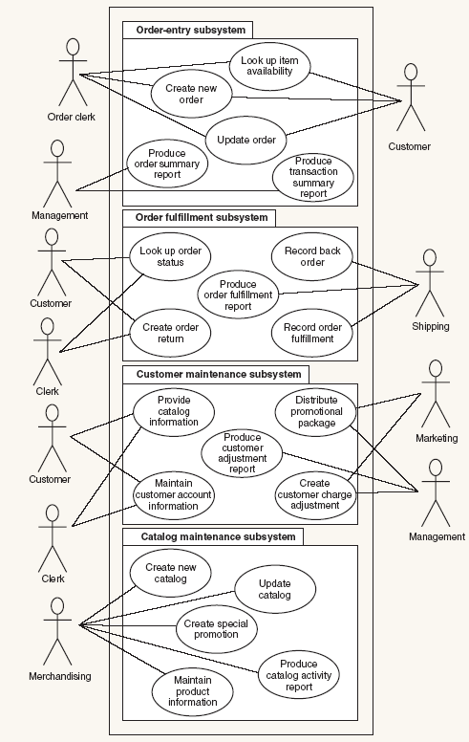
Figure 2.1: Use Case Diagram of <Name of the System>

  - Product Perspective
This subsection of the SRS should put the product into perspective with other related products. If the product is independent and totally self-contained, it should be so stated here. If the SRS defines a product that is a component of a larger system, as frequently occurs, then this subsection should relate the requirements of that larger system to functionality of the software and should identify interfaces between that system and the software.
A goal diagram (as example below) showing the major components of the larger system, interconnections, and external interfaces can be helpful
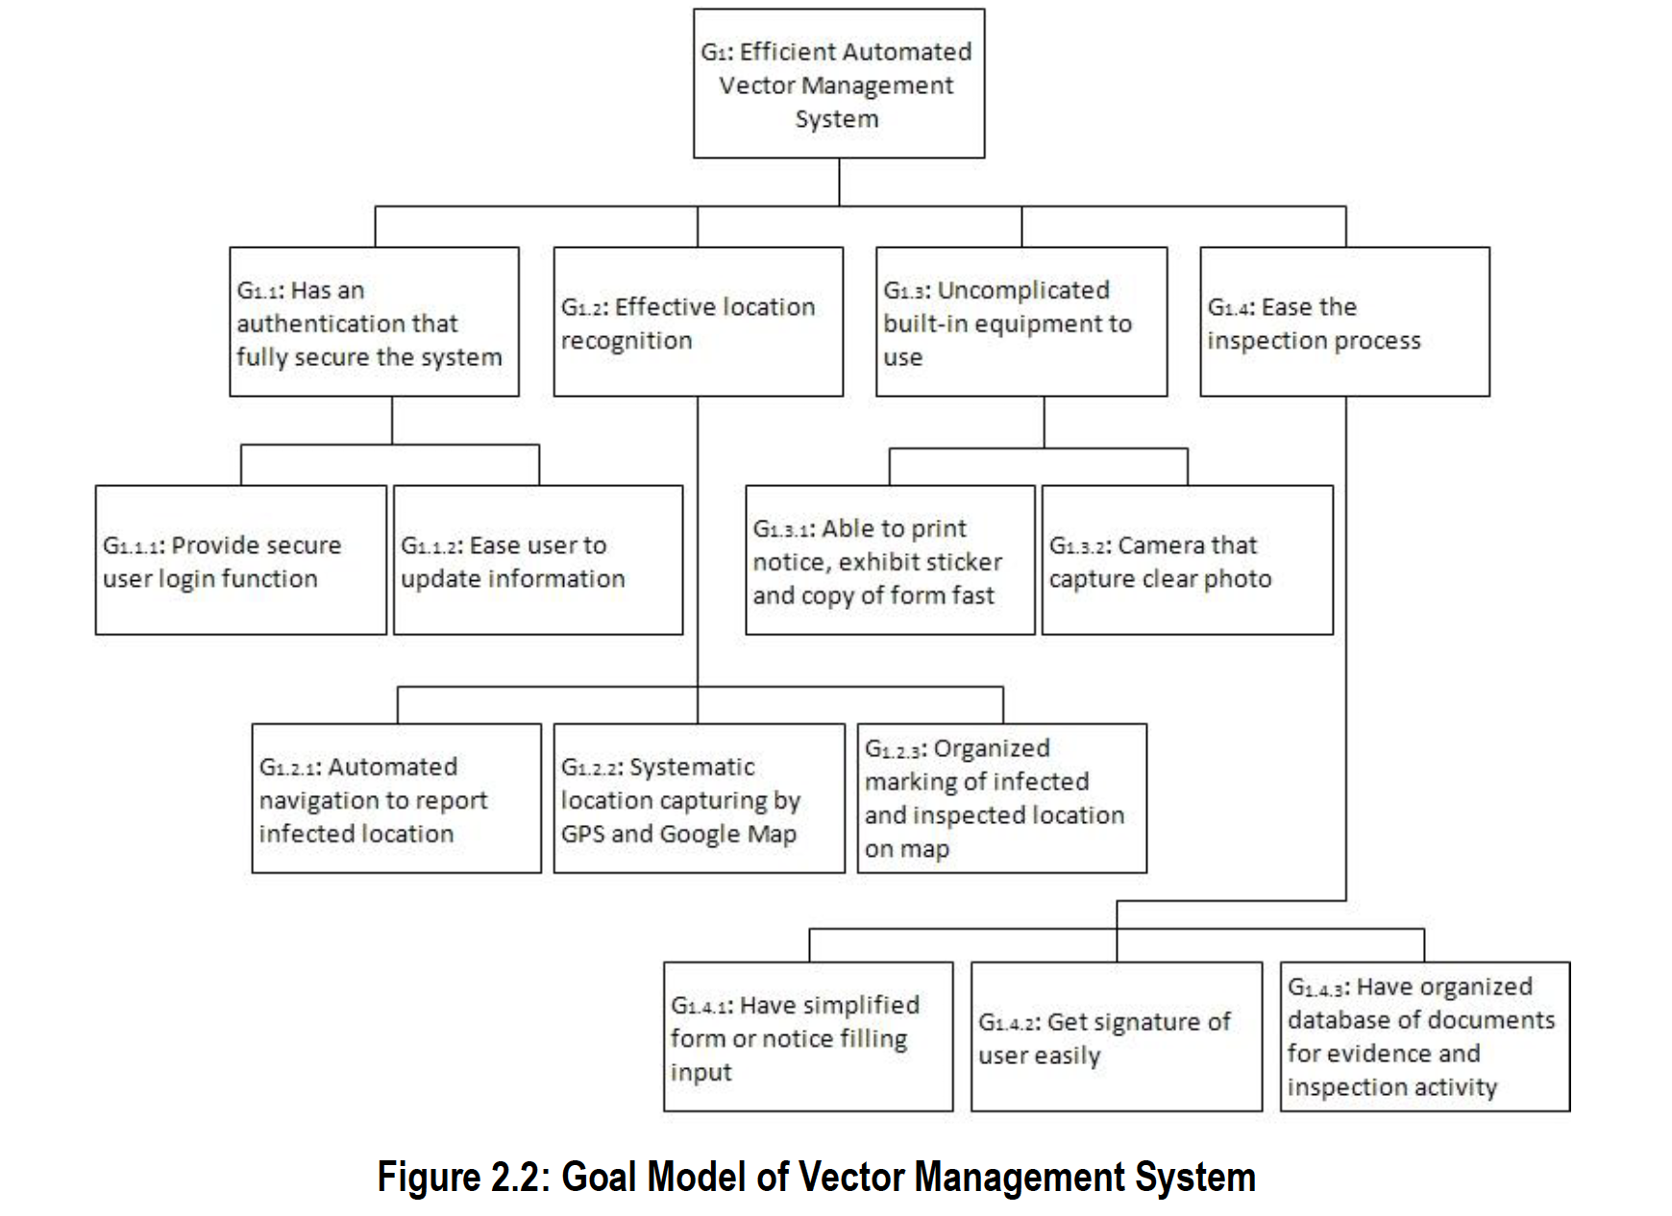.
[Organize as below 2.1.1 to 2.1.8]
Explain the perspective of the software product here by describing the goal diagram.

  - Product Functions
This subsection of the SRS should provide a summary of the major functions that the software will perform. For example, an SRS for an accounting program may use this part to address customer account maintenance, customer statement, and invoice preparation without mentioning the vast amount of detail that each of those functions requires.
Sometimes the function summary that is necessary for this part can be taken directly from the section of the higher-level specification (if one exists) that allocates particular functions to the software product. Note that for the sake of clarity:
- The functions should be organized in a way that makes the list of functions understandable to the customer or to anyone else reading the document for the first time.
- Textual or graphical methods can be used to show the different functions and their relationships. Such a diagram is not intended to show a design of a product, but simply shows the logical relationships among variables.

Summarize the major functions (by use case) of the system by referring to the use case diagram, Figure 2.1.

  - User Characteristics
This subsection of the SRS should describe those general characteristics of the intended users of the product including educational level, experience, and technical expertise. It should not be used to state specific requirements, but rather should provide the reasons why certain specific requirements are later specified in Section 3 of the SRS.
Describe here...

  - Constraints
This subsection of the SRS should provide a general description of any other items that will limit the developer’s options. These include:
- Regulatory policies;
- Hardware limitations (e.g., signal timing requirements);
- Interfaces to other applications;
- Parallel operation;
- Audit functions;
- Control functions;
- Higher-order language requirements;
- Signal handshake protocols (e.g., XON-XOFF, ACK-NACK);
- Reliability requirements;
- Criticality of the application;
- Safety and security considerations.

State here…

  - Assumption and Dependencies
This subsection of the SRS should list each of the factors that affect the requirements stated in the SRS. These factors are not design constraints on the software but are, rather, any changes to them that can affect the requirements in the SRS. For example, an assumption may be that a specific operating system will be available on the hardware designated for the software product. If, in fact, the operating system is not available, the SRS would then have to change accordingly.
List the factors here…

Specific Requirements
This section of the SRS should contain all of the software requirements to a level of detail sufficient to enable designers to design a system to satisfy those requirements, and testers to test that the system satisfies those requirements. Throughout this section, every stated requirement should be externally perceivable by users, operators, or other external systems. These requirements should include at a minimum a description of every input (stimulus) into the system, every output (response) from the system, and all functions performed by the system in response to an input or in support of an output.
[Include domain model i.e. class diagram without the operation part – only attributes without details on visibility and type, explain each class and its attributes including the relationships among the classes, see the example of Customer Support System. The diagram must be assigned a unique id]
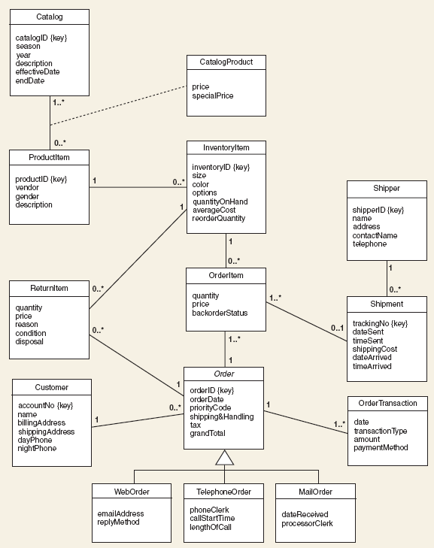
DM001 - Domain Model of <Name of the System>

[Include behaviour model of selected class i.e. UML state transition diagrams, see the example of TrainDoor Class below. Each state transition diagram must be assigned its own unique id. Briefly describe the state diagram.]

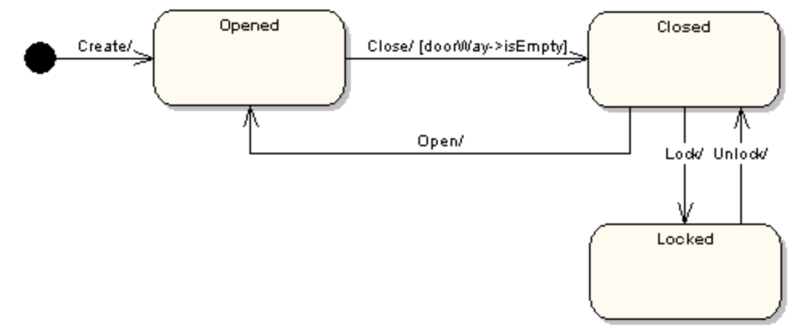
STD001 - State Transition Diagram of <Name of the Class>

As this is often the largest and most important part of the SRS, the following principles apply:
- Specific requirements should be stated in conformance with all the characteristics described in 4.3. (IEEE Std 830-1998)
- Specific requirements should be cross-referenced to earlier documents that relate.
- All requirements should be uniquely identifiable. [Provide ID to each functional requirement]
- Careful attention should be given to organizing the requirements to maximize readability.
[Section 3.1.1 to Section 3.1.4 provide the details of what described in 2.1.2 to 2.1.5. Consider to organize Section 3.2 by the modules i.e. map each feature with each module and map respective use case in the module with its functional requirement. For each functional requirement, indicate its details using use case description. Include activity diagram for each use case i.e. functional requirement.]

  - User Story List
- List all user stories in a table. Need to include the abuser story
ID | User Story Name | Priority (Low / Medium / High) | Status (In Progress / Backlog / Done)

    - Detailed User Story Specifications
    - Module <Name of Module1>
State briefly the functional requirements (use cases) that are available in this module.

      - US001: <User Story ..>
- Expands each user story with acceptance criteria, scenarios, and supporting details.

Refer to Table 3.1 for improvised user story in terms of enhancement for related requirements (ID, Natural Language-NL requirement specification for functional, quality & constraints types, priority based on Kano-types).
Refer to Table 3.2 for the improvised abuser story.

Table 3.1: User Story
User Story ID: | ID of the story
User Story Name: | [Short name for the story]
User Story Statement: | As a [type of user], I want [an action or feature] so that [a benefit or reason].
Description / Notes: | - Brief elaboration of what the feature does, constraints, or context.
Acceptance Criteria (Given / When / Then format): | - Given [precondition], When [action], Then [expected outcome].  - …
Priority: | High / Medium / Low
Status | Backlog / In Progress / Done
Dependencies | [List any prerequisite user stories or features]
Related Requirements | ID | Requirement | Priority (Kano)

Table 3.2 Abuser Story
Abuser Story ID: | ID of the story
Abuser Story Name: | [Short name for the story]
Abuser Story Statement: | As a(n) <type of attacker>, I want to <perform malicious action>, So that <I can achieve a harmful outcome>
Description / Notes: | - Brief elaboration of what the feature does, constraints, or context.
Security Acceptance Criteria (Given / When / Then format): | - Given [precondition], When [action], Then [expected outcome].  - …
Priority: | High / Medium / Low
Status | Backlog / In Progress / Done
Dependencies | [List any prerequisite user stories or features]
Related Requirements | ID | Requirement | Priority (Kano)

Include system activity diagram for each respective user story. See example below for Manage Delivery Order scenario.
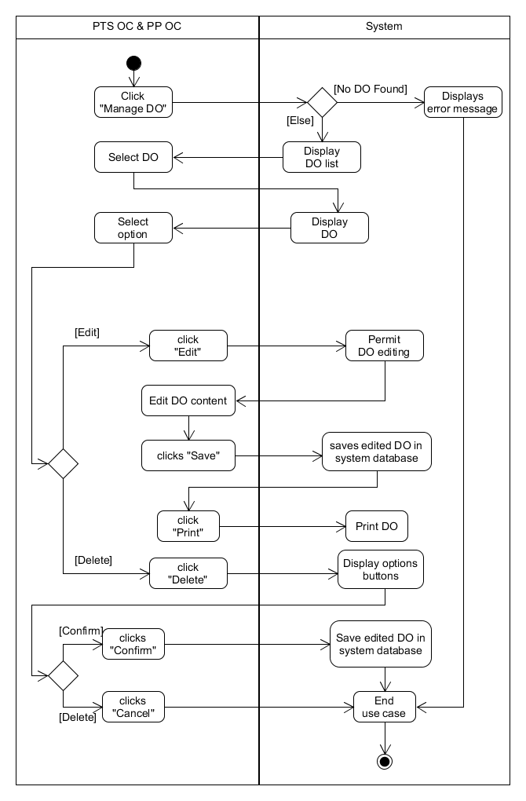
Figure 3.3: Activity Diagram of <Name of User strory/Scenario if more than one scenario>

      - US002: <User Story ..>
      - US003: <User Story ..>

    - Module <Name of Module2>
      - US004: <User Story ..>
      - US005: <User Story ..>

3.2.n Module <Name of the n Module>
…
  - Non-Functional Requirements
Describes performance, security, usability, and other quality requirements tied to specific user stories

  - Mockup / Wireframes
Presents visual representations of screens, workflows, or layouts to support story understanding

  - Revision History
- Tracks changes made to the document, including dates, descriptions, and authors.

Appendices
[Include any related documents, screenshots of legacy system, interview and survey questionnaires – that were observed and compiled to understand the system and it’s relevant context – boundary, scope, objects, interfaces]
- Appendix A: Originality/Similarity Report
  - Attach the originality/ similarity report (.pdf file) from Turnitin checking.
  - UTM teaching and learning best practice for plagiarism policy is similarity index must less than (=<) 20%
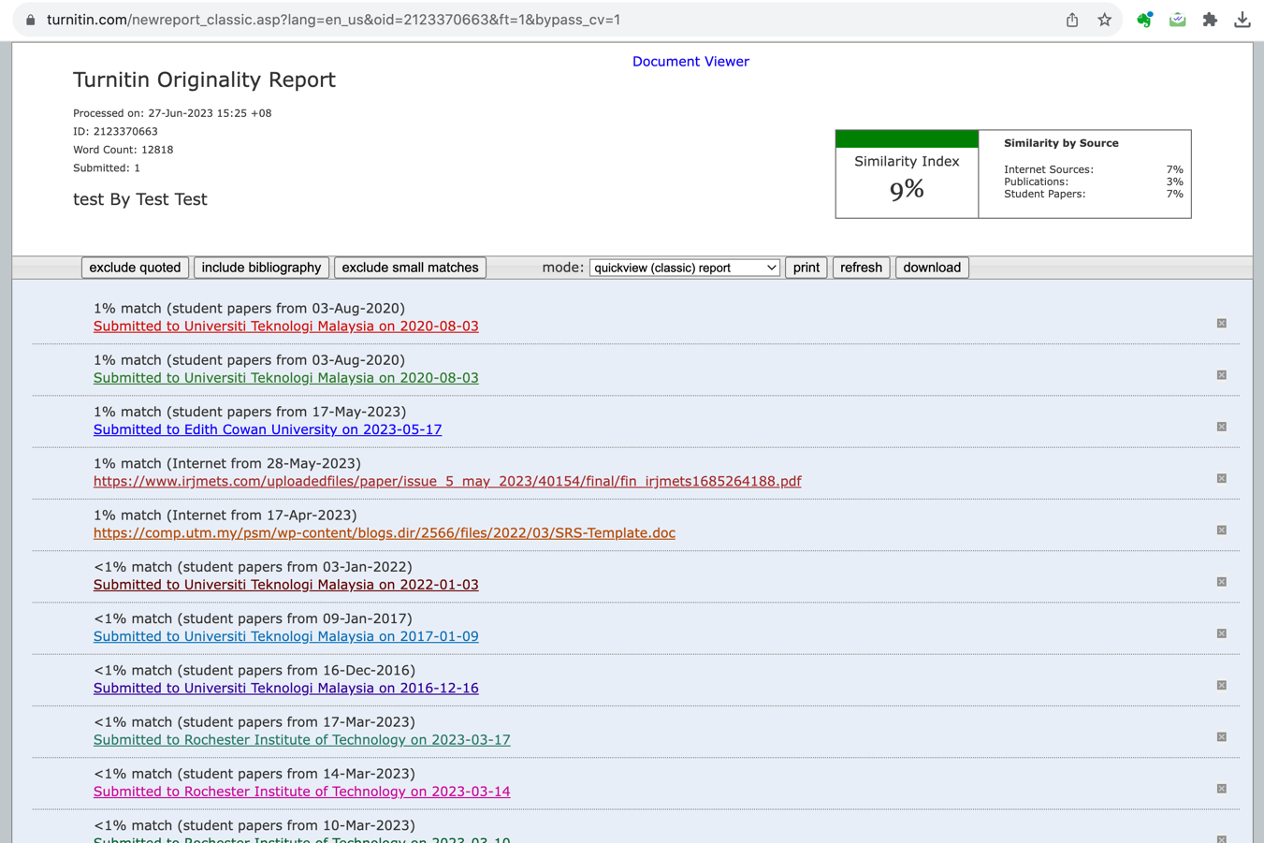

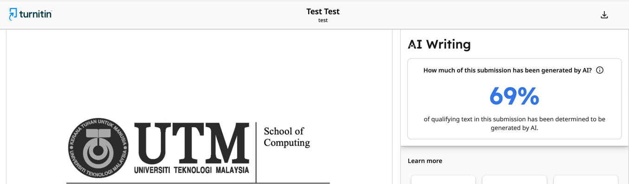

- Appendix B: List of Prompts Used
  - Include verifiable evidence of the use of Generative AI tools such as ChatGPT, QuillBot, etc., in the creation of your assignment.
  - This evidence may include screenshots and URL links
  - Failure to provide this evidence when actually you are using generative AI in your work will result in ethical violations and may lead to plagiarism penalties, ultimately resulting in a grade deduction to zero marks.

* Generative Artificial Intelligence refers to a type of artificial intelligence technology that can produce various types of content, including text, images, audio, and synthetic data
Example: Screenshot
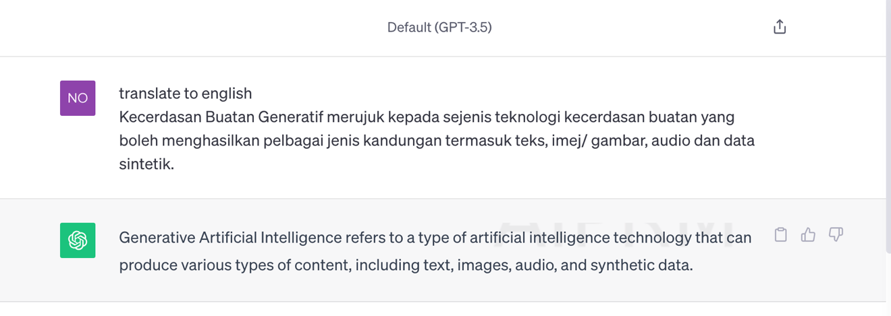
Figure: Screenshot Generative AI translation from BM to English
Example: URL
https://chat.openai.com/share/0ff33fdd-9b7f-407c-9b74-b744ec698a7e>

